Study on the Self-elastic Damping Plate of Frictionless

Compressor Plate Valves*

Shu-lin PAN

School of Chemistry and Chemical Engineering
Guangxi University, Nanning 530004, China
Telephone: 086-0771-3232842
Fax: 086-0771-3233718
Email: Panshulin@163.com

Sheng-fang OU

Wenzhou Zheou Valves Manufacture Limited Company
Wenzhou 325027, China
Telephone: 086-0577-88638166
Fax: 086-0577-88612377
Email: Zheouqifa@vip.sina.com

Qian-ci Mo, Zhao-xia LU, Jia-ye GAN

School of Chemistry and Chemical Engineering
Guangxi University, Nanning 530004, China
Telephone: 086-0771-3231446
Fax: 086-0771-3233718
Email: Mqc13@163.com

*Supported by the Support Program for 100 Young and Middle-aged Disciplinary Leaders in Guangxi Higher Education Institutions
Abstract: A new self-elastic damping plate of the frictionless compressor plate valve is presented. There are not elastic arms in the center of this damping plate, and the damping plate is designed as a self-elastic plate. Thus, the larger spring force can be loaded on the damping plate because of its higher stiffness coefficient. But its stresses in the working process are smaller. The reliability of this valve becomes higher. The stiffness coefficient, stresses and equivalent motion mass of the damping plate are calculated by means of ANSYS, which is a large-scale finite element analysis software. And then methods for their engineering calculation are proposed for the convenient design of the self-elastic damping plate. The valves with self-elastic plates are used in series of large and middle-sized compressors, and the results are good.

Keywords: compressor, plate valve, self-elastic damping plate, engineering calculation

- INTRODUCTION

Valves are important parts in reciprocating compressors, and they are very easy to damage. There are many kinds of compressor valves. Among all kinds of valves, the plate valves are widely used in large and middle-sized reciprocating compressors. At the same time, the frictionless plate valves are widely used in compressors free of oil and with high speed of rotation because no friction occurs in the working process. In the traditional frictionless plate valve, the damping plates have elastic arms nearby the fixed central part. In general, the stiffness coefficients of the arms are lower, and they are easy to rupture at both ends because of higher stresses^{[1]}. Therefore, only smaller spring forces can be loaded on the damping plates, and the reliability of the traditional frictionless plate valve is lower. In order to obtain the high reliability of the valves, a new self-elastic damping plate of the frictionless compressor plate valve is presented in this paper^{[2]}.

- STRUCTURE OF THE COMPRESSOR PLATE VALVE WITH SELF-ELASTIC DAMPING PLATES

The frictionless plate valve with self-elastic damping plates is shown as Fig.1. From top to bottom of Fig.1, there are sequentially the valve seat, the valve plate, the lift gasket, the self-elastic damping plates and the valve guard. There are spring holes in the valve guard. The slightly outside holes are filled with springs pressing on the damping plates, and the slightly inside holes are filled with springs pressing on the valve plate. The difference between the plate valve with self-elastic damping plates and the traditional frictionless plate valve with damping plates is as follows. The self-elastic damping plate has no elastic arms nearby the fixed central part. It is designed as a self-elastic plate. Every ring of the self-elastic damping plate is connected by ribs. When the spring forces are loaded on the damping plate, the ribs deform. Every ring except the outermost ring of the self-elastic damping plate is cut by the straight channels. On one hand, the springs pressing on the valve plate can pass through the channels. On the other hand, the stiffness of the self-elastic damping plate itself can be lowered.
The working process of the plate valve with self-elastic damping plates is the same as that of the traditional frictionless plate valve with damping plates.
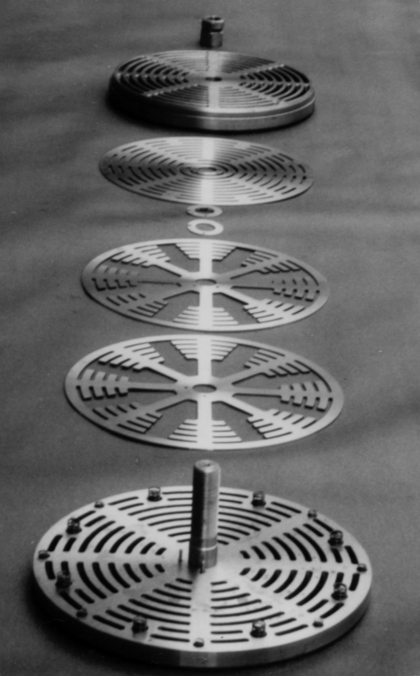

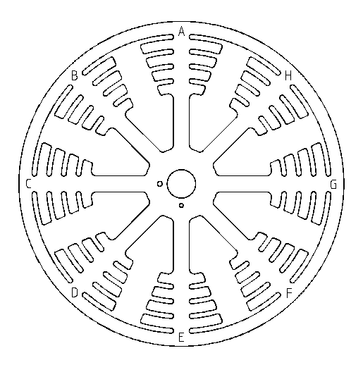

Fig.1 Plate valve with self-elastic damping plates Fig.2 Self-elastic damping plate

- CACULATION OF THE SELF-ELASTIC DAMPING PLATE

In order to analyze the dynamic characteristics of the valves, the stiffness coefficient, stresses and the equivalent motion mass of the damping plate should be calculated in the design of the plate valve with self-elastic damping plates. The finite element method is usually adopted to calculate the self-elastic damping plate because of its complicated shape. Now, the self-elastic damping plate shown in Fig.1 is calculated by ANSYS.
The vertical view of the self-elastic damping plate in Fig.1 is shown as Fig.2. The central part where the self-elastic damping plate clings to the lift gasket is fixed. The external circle of the outermost ring is free. In Fig.2, there are springs at the places of A-H. The structural parameters of the self-elastic damping plate in Fig.2 are as follows. The external diameter of the outermost ring is 332mm. The width of the ribs is 16mm. The external diameter of the central fixed ring is 74mm. The external diameter of the lift gasket is 52mm. The width of the outermost ring is 13mm. The width of every middle ring is 10mm. The width of the arc channels between rings is 5mm. The thickness of the self-elastic damping plate is 2mm. The diameter of the circle which is constituted by the center points of the springs pressing on the damping plates is 312mm. The width of the above-mentioned straight channels is 30mm. The material of the self-elastic damping plate is 3Cr13 stainless steel.
The stiffness coefficient K_{s} of the self-elastic damping plate is defined as follows:
Where, F_{s} is the total spring force on the damping plate, and W_{max} is the deflection of the self-elastic damping plate.
The equivalent motion mass of the self-elastic damping plate can be calculated by the Rayleigh method. The static deflection curve surface of the self-elastic damping plate is assumed to be its vibration shape^{[3]}. At the same time, the finite element method is adopted. The equivalent motion mass M_{eq} is obtained as follows:
Where, ρ is the density of the self-elastic damping plate, W is the average deflection of the element, and ΔV is the volume of the element, and the subscript i is the element number.
By ANSYS, the calculation results of the self-elastic damping plate shown as Fig.2 are obtained. Its stiffness coefficient is 32.4KN/m, and its equivalent motion mass is 0.318kg. The maximum stress of the self-elastic damping plate is 44.6MPa while its maximum deflection is 1mm.
The calculation by ANSYS is too complicated for the engineering design of the self-elastic damping plate. Considering that the deformation of the rib in the self-elastic damping plate is similar to that of a cantilever, the formula by which the stiffness coefficient of the self-elastic damping plate is approximately calculated is given as follows^{[4]}:
Where, n_{r} is the number of ribs, EI is flexural rigidity of the rib, l is the distance from the root of the rib to the external circle of the outermost ring, a is the distance from the center point of the spring to the root of the rib, and C_{K} is the correction factor for the stiffness coefficient. C_{K} is mainly influenced by the relative width λ_{r}, which is defined as the ratio of the width of the rib to the width of the outermost ring. In general, the values of λ_{r} vary from 1 to 2, and C_{K} is valued between 1.2 and 1. The greater λ_{r} is, the smaller C_{K} is.
The calculation formula for the maximum stress of the cantilever is adopted to calculate the maximum stresses of the self-elastic damping plate in the engineering design^{[4]}. The formula is as follows. In fact, the maximum stresses of the self-elastic damping plate are smaller than those of the cantilevers when the loaded forces are the same. The following formula is safe for the design of the self-elastic damping plate.
where, b is the width of the rib, and h is the thickness of the self-elastic damping plate.
The calculation formula for the equivalent motion mass of the self-elastic damping plate is as follows:
where, n is the number of the working rings. m_{i} is the mass of the working ring, W_{ci} is the deflection of the barycenter of the working ring, and the subscript i is the ring number. W_{cmax} is the maximum deflection of the self-elastic damping plate. m_{r} is the mass of the ribs between the innermost working ring and the central fixed ring. W_{re} is the deflection of the end of the rib by the innermost working ring. When W_{ci}, W_{cmax} and W_{re} are calculated, the self-elastic damping plate is regarded as cantilevers. C_{e} is the correction factor for the equivalent motion mass, and C_{e} is valued between 1.01 and 1.06. When the relative width of the rib λ_{r} is smaller or the number of the working rings n is greater, C_{e} is greater.

- CONCLUSION

Compared with the traditional damping plate of the frictionless compressor plate valve, the stiffness coefficient of the self-elastic damping plate is higher. Its stresses in the working process are smaller. The larger spring force can be loaded on the damping plate in the design of the valve. In addition, the stiffness coefficient of the self-elastic damping plate is easy to adjust by the change of the structural parameters.
The calculation formulas of the stiffness coefficient, the maximum stresses and the equivalent motion mass are simple and convenient, and they meet the demands of the engineering design. So far, the plate valves with self-elastic damping plates have been used in 18 types of large and middle-sized compressors. Sizes of the valves range from 381mm to 150mm. In practice, the self-elastic damping plates never rupture, and the valves have higher reliability.

REFERENCES

[1] Shu-lin PAN. Study on the working characteristics of plate valves in reciprocating compressors. Doctor's degree thesis, Xi'an Jiaotong University, Xi'an, China, 1996.
[2] Shu-lin PAN, Lian-hua XIE & Lin YANG. A type of compressor plate valves. Chinese patent: ZL98217013.0, 1999.
[3] Zhen-hua NI. Vibration mechanics. Publishing House of Xi'an Jiaotong University, Xi'an, China, 1989.
[4] Qian-ci Mo. Study on the self-elastic damping plates of the compressor plate valves. Master's degree thesis, Guangxi University, Nanning, China, 2005.

